How to set up an NHS login to register for MyWay Diabetes using your Linkage Key and codes.

1. Get your Linkage Key and codes from your “Patient Online Services - registration letter” or from your Patient Access account ([How to find your Linkage Key and codes in Patient Access](http://creechmc.gpsurgery.net/wp-content/uploads/sites/283/2021/09/Creech_How-to-find-your-Linkage-Key-and-codes-in-Patient-Access.docx))
2. Visit <https://patientaccess.mydiabetes.com/>
3. Click on “Register” as shown below

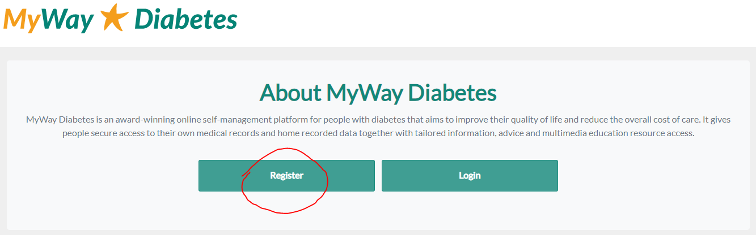

1. Click to “Register using NHS login”. This will then take you to the site to set up an NHS login. Please follow the instructions on the screen.

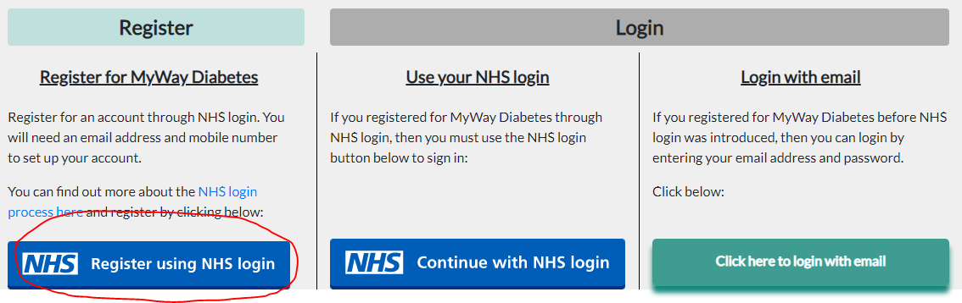

1. 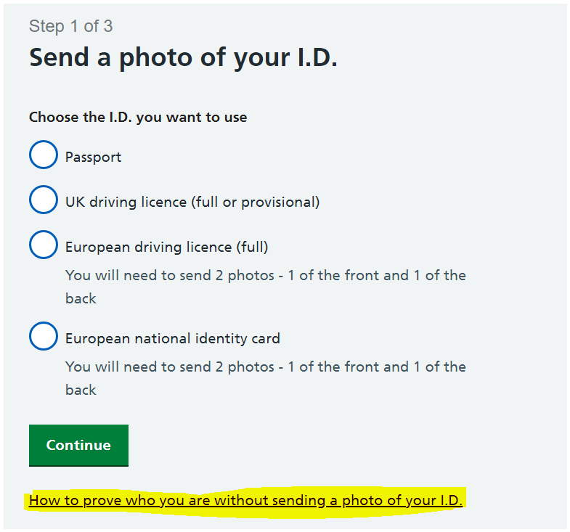When you are asked to verify your identity, you can use your Linkage key and codes instead. Please click on the “How to prove who you are without sending a photo of your I.D.” link (highlighted in yellow below):

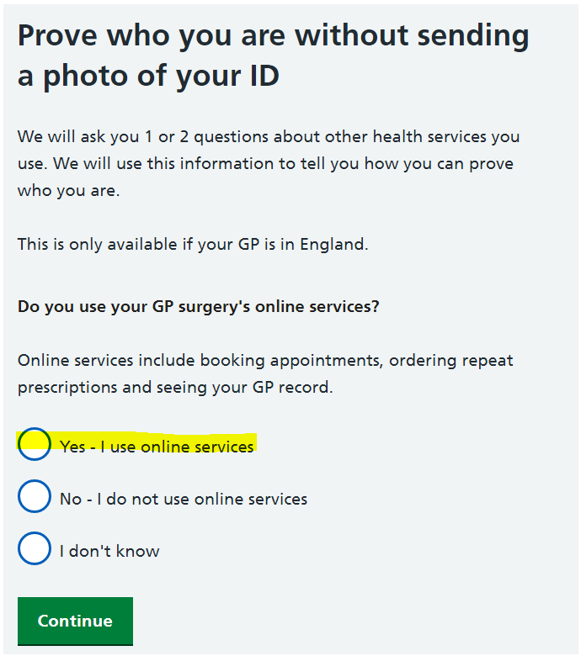

1. Please select “Yes - I use online services”:

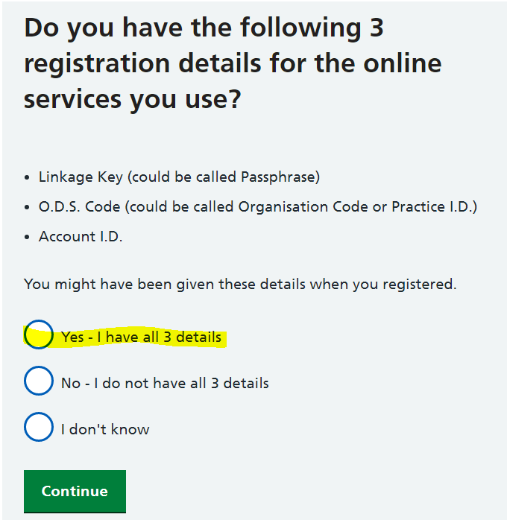

1. Followed by “Yes – I have all 3 details”:

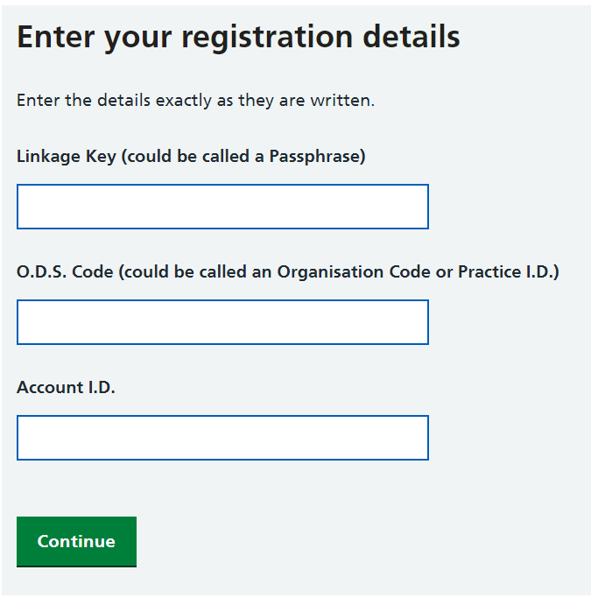

1. You can then enter the codes as in your registration letter email: